Essential guide to the Dordogne
In deepest France, Anthony Peregrine knows where to go for castles, cave art and lunch
Anthony Peregrine
April 9 2017, 12:01am, The Sunday Times
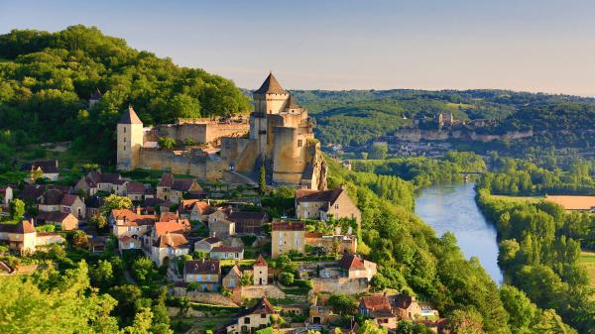
The village of Beynac rises above the DordogneCALLE MONTES/GETTY IMAGES
Share
Save
Travelling to the Dordogne is returning to the world as it was back then, and still should be now. The landscape is defined by rivers, forests and old-fashioned farming. Gold-stone villages and small towns continue the countryside by other means.
Round here, man and environment have been getting along fine since palaeolithic times, when Stone Age folk discovered a region of mellow wellbeing — and of ample food, shelter and caves to decorate. They settled in abundance, establishing the region as the future world HQ of prehistory. Subsequent tough times — the Hundred Years’ War, religious conflict, poverty, peasant insurgency — gave the land a harder edge and a sprinkling of chateaux.
Then the world swept on. The region was bypassed. Countryside and values were left untouched. This wasn’t invariably splendid — it’s less than 150 years since remote yokels in Hautefaye lynched, burnt and, by some accounts, ate a local noble. But Dordogne people are generally more convivial than that. More exacting, too, gastronomy-wise.
The Dordogne embodies the sunlit certainties of an indistinct past — when front doors were unlocked and kids could roam — so, obviously, it draws in civilised Britons. “Dordogneshire”, the wiseacres say. Not really. A twist in the lane, a 15-minute woodland walk, a lunch of foie gras, confit de canard, a bottle of Pécharmant red... and you’re a hell of a way from the Home Counties.
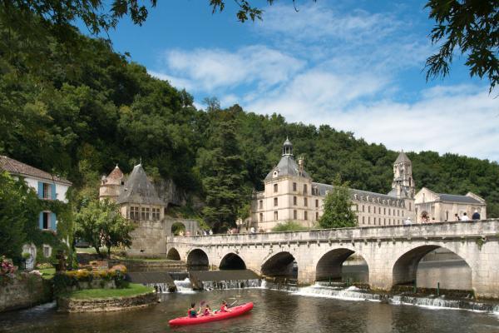
Boating at Brantôme
The days out
A day on the Dordogne
If not the prettiest village in France, La Roque-Gageac is in the top five. The Dordogne loops on one side, cliffs rise straight up on the other and, crammed between, the village clambers over itself for space, creating a vertical jumble where past and present, private and public, greenery and gold stone get disarmingly confused. Take a gabare, a flat-bottom boat, for proper appreciation (slow, soulful) of river and surrounds, and no worries about the freight they once plied upstream and down (£8; gabarres.com).
Now to St-Cyprien and up the valley sides to Péchalifour, a honey-hued hamlet where anyone in their right mind would want to live for ever. You’ve come for the truffles — crucial components of Dordogne life. Edouard Aynaud will bounce you round the truffle groves. After the dog does the snuffling, he’ll let you dig up a couple before it’s back to the farmhouse, where his wife, Carole, prepares a terrific truffle-laden lunch. This is infinitely more fun than one usually gets from fungus (half-day truffling and lunch £55; truffe-perigord.com).
Then it’s back to riverside Beynac, almost as seductive as La Roque-Gageac. Way up top, the chateau glowers, still ready for a fight. Held by the French during the Hundred Years’ War, it stared defiance across the river, from where English-held Castelnaud stared back. Perched on a rock outcrop, its village below, Castelnaud’s chateau is notable for arms, armour and siege machines (£8.40; castelnaud.com).
For dinner, to Domme — up the hill, through the Porte des Tours and into the bastide built to keep the good guys out. Cabanoix, Chataîgne & Cie is the funky spot for when hunger stalks (three courses, £27; restaurantcabanoix.com). Then your time is your own. Domme affords atmospheric evening ambling.
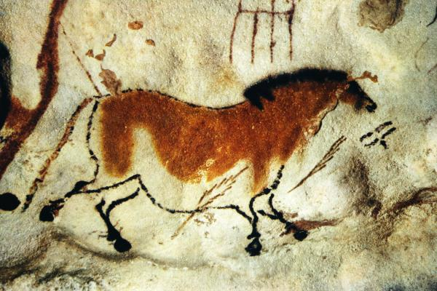
Cave art at Lascaux IVROBERT HARDING/GETTY IMAGES
Meet the cavemen in the Vézère valley
This tributary of the Dordogne is a beauty, flanked by pasture, forest and cliffs bursting with geology. Stone Age man swirled through, leaving behind evidence of his passage in unprecedented quantities. There are nearly 150 sites in total. If you’re not choosy, you’ll go cave-mad.
Start in Montignac, at the International Centre for Cave Art — Lascaux IV to you and I. Inaugurated last December, the centre has as its focal point the recreation of almost the entirety of the world’s most richly painted cave system. We can’t visit the real thing (just up the wooded hillside) because our breath would wreck the 17,000-year-old art, but the facsimile is stunning, surging with colour, aurochs, ibex, deer and a beast experts call “a unicorn”, which I reckon is just a badly painted bull. We know little of the makers except that they could portray (most) animals as expertly as modern artists do. The whole is brilliantly supported by exhibitions, interactive this-and-thats, and cracking evocations of our common humanity (£14;lascaux.fr).
Downstream, the Roque Saint-Christophe is a kilometre-long, 80-metre-high rock face with five levels that were inhabited for some 55,000 years, through to the Renaissance. It’s an engrossing scramble of soaring terraces, defence works and cave shelters (£7.25; roque-st-christophe.com).
Centre point of the valley is Les Eyzies and the National Museum of Prehistory, integrated cleverly into the rock face. The museum eschews frivolity to chart the flow of prehistoric human affairs. There’s no doubt that, despite being awesome artists, our forebears were otherwise a bit slow. We have gone from the horseless carriage to the smartphone in a century. They spent millennia perfecting the arrowhead (£5; musee-prehistoire-eyzies.fr).
Up in the dark, narrow Font-de-Gaume, a mile away, you’ll find the only original polychrome cave paintings on view in the Dordogne. Daily visitor numbers are restricted, so book ahead (00 33 5 53 06 86 00). There are startling depictions of bison and horses, plus the most moving of all the Dordogne’s images: a stag bending to lick the face of a kneeling doe. Book the nearby Combarelles caves on the same number for an extraordinary collection of engravings of animals and somewhat schematic humans (£8.50 each; joint ticket £13.50; sites-les-eyzies.fr).
You might end with a blast of underground showbiz at the vaulted Gouffre de Proumeyssac. “Cathedral of crystal”, they call the cavern, and that’s spot-on. The rocky growths are, frankly, beautiful, and well flattered by lights and music (£7.70; gouffre-proumeyssac.com). That’s enough caves. Now go and eat.
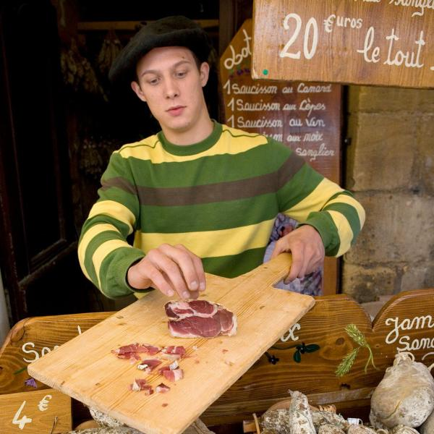
Stock up on charcuterie at Sarlat’s marketDOUG PEARSON/GETTY IMAGES
Market day in Sarlat
You need to be in Sarlat on a Wednesday or Saturday morning, when the most Rabelaisian market in southwest France colonises the country’s finest medieval/Renaissance centre. It’s a perfect historical match — commerce fits right into the Dordogne’s standout town. Market over, meander streets so well preserved, you expect peasants and pageants at every turn. Note the cathedral and, opposite, the home of the 16th-century philosopher Etienne de La Boétie. A precocious fellow, he was 18 when he wrote his classic treatise on tyranny, Discourse on Voluntary Servitude. Key sentence? “Tyrants seem big only because we are on our knees.” He died at 33.
Then I’d stroll some more before lunch near the station at the Michelin-starred Le Grand Bleu (lunch menu £31; legrandbleu.eu). In the afternoon, shop for duck- and goose-based requirements. Every other store in Sarlat seems to sell foie gras, so end up, as I do, at Grolière, on Rue de la Liberté (foiegras-groliere.com). Subsequently, I’d return to Place de la Liberté, take a terrace table, order a beer and wonder where my real life went.
Paddle down the Dronne
The Dordogne is as celebrated for recreational canoeing as it is for ducks and geese. In high summer, the Dordogne and Vézère rivers jam up like the M25. So we’re going north to Brantôme and the Dronne, partly because Brantôme is a lovely place to visit anyway. Backed into a cliff overlooking the town, the semi-troglo 8th-century abbey is stirring, the monumental bas-relief in the Last Judgment cave a revelation (£4.75; perigord-dronne-belle.fr).
Allo Canoës will provide a boat for between an hour and three days (allo-canoes.com). Go for the two-person canoe, 7½-mile option, starting late morning, for £25. It includes a paddle round Brantôme itself — there’s water everywhere, and a weir or two to negotiate — then a float downstream to Bourdeilles. Take in the double chateau — part medieval, part Renaissance (£7; semitour.com) — before the shuttle back to Brantôme.
Perfect Périgueux
The county capital is an ideal country town — big enough to entertain, small enough not to overwhelm. Someone rocketed forward from the Renaissance would feel at ease in the pedestrian centre, notably the fancy stone frontages on Rue Limogeanne (look for the ornate Favié tableware shop at No 5; coutellerie-favie.fr). You need to see the cathedral of St Front: its cupolas suggest it has been shipped direct from the Middle East. On Wednesdays and Saturdays, there’s a cracking market just outside; otherwise, stroll streets alive with ancestral commercial vigour — people have lived well here for a long time. Eaten well, too. Make for La Taula, across from the cathedral (two-course lunch £16, four-course dinner £28; restaurantlataula-perigueux.com).
The greatest garden
Best garden in the Dordogne? A close-run thing, but I’m going for the Manoir d’Eyrignac, in Salignac-Eyvigues, northeast of Sarlat. The Sermadiras de Pouzols de Lile family has been in place for 22 generations, the most recent of which has sculpted thousands of box trees, hornbeams, cypresses and others into a 25-acre embroidery — a bewitching homage to French gardening formality. Unlike the British, French gardeners like to think they have nature disciplined. Here, with hornbeam tailored around yew trees, alleys like vegetal Champs-Elysées, water sources and an all-white garden, the illusion is complete. We are at the summit of precision topiary, where every prospect pleases (£11; eyrignac.com).
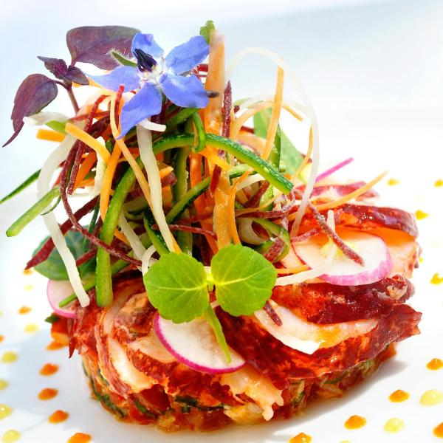
Dinner at Château de la Treyne is a treatDAVID NAKACHE
Where to eat
La Garrigue Haute, Prats-de-Carlux
The Boucherie family have farmed here, in the yeomen’s village of Prats-de-Carlux, since 1855. In the farmhouse dining room, they lay on their own duck or goose with Sarladaises spuds (fried in duck fat, with garlic and parsley) and much else besides. It’s the real thing. Menus from £17, including wine and coffee; lagarriguehaute.fr
Château de la Treyne, Lacave
Perched above the River Dordogne, the chateau’s 17th-century candlelit terrace is where you propose to a loved one. If she refuses, save up and bring someone else next year. We’re in fairy-tale territory: damsels certainly, knights perhaps, and Stéphane Andrieux’s Michelin-starred cooking. It’s bound to work eventually. Dinner menu £82; www.chateaudelatreyne.com
La Belle Etoile, La Roque-Gageac
The summer terrace affords as fine a view (over the River Dordogne and far away) as anyone needs while eating. The same family have been serving refined versions of local things — duck, Limousin beef, pike-perch — for three generations. They’re on top of the job. Menus from £25; hotel-belle-etoile-dordogne.fr
Bistrot du Presbytère, Queyssac
Opposite the church in the prettiest possible hamlet, one comes upon this place with the joy similar to that of finding a good, affordable spot concealed in the Cotswolds. Menus from £18; bistrot-presbytere-queyssac.fr
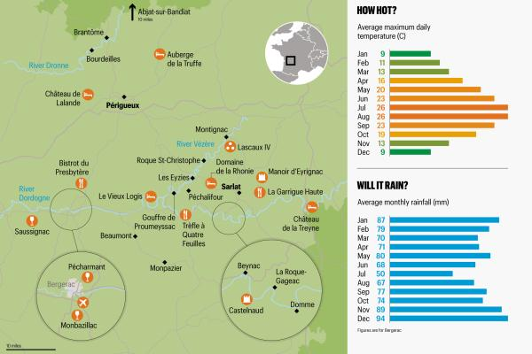
L’Auberge du Trèfle à Quatre Feuilles, Siorac
The Four-leafed Clover is indeed a lucky discovery. Bang in the centre of this valley village, it offers a youthful take on trad cooking and weapons-grade charm. Menus from £22; letrefle4feuilles.com
L’Imparfait, Bergerac
Almost certainly the best table in Bergerac, with beams, a chimney and a little pavement terrace in the old town. Next door, the Plus-Que-Parfait’s pleasing array of craft beers works well before dinner, or after, or both. Dinner menu from £42; imparfait.com
Wine: better value than Bordeaux
Pound for pound, the wines of the Dordogne — from around Bergerac — are better value than the wines of Bordeaux, right next door. They’re produced using much the same soil, the same grape varieties and similar techniques. All they haven’t got is “Bordeaux” on the label.
For proof, start at the Maison des Vins in Bergerac. Get the story of the nine local appellations — which you’ll forget immediately — and a tasting (vins-bergeracduras.fr). Nearby, incidentally, is the only tobacco museum in France — Bergerac remains the home of French baccy-growing — so that’s two vices covered in 200 yards. It’s hard not to warm to this town (£3.50; www.france-tabac.com).
Now travel south to Monbazillac, where the pointy-roofed chateau is HQ for the mellow white wines of the same name. The best of these are like drinking liquid gold, as good as Sauternes and significantly cheaper (chateau visit and tasting £6.50; chateau-monbazillac.com). Then round to Saussignac, home to an equally good mellow white wine (as well as reds and pinks) and to the Feely family. Caroline and Sean are South Africans of Irish extraction. They provide belting wines, gîtes, introductions to organic viticulture, walking tours and anything else you might wish for related to wine (gîtes from £555 a week; chateaufeely.com).
Finally we curve to the north of Bergerac, into the Pécharmant district. Here they make red wines of staying power, none better than those of the Dubard family, at Farcies du Pech. The Dubards, too, have staying power. They’ve been around for generations on a stately estate, where they’ll provide B&B for two for £102. Then Serge Dubard, a convivial chap if ever there was one, will walk you round the estate and winery (farciesdupech.com).
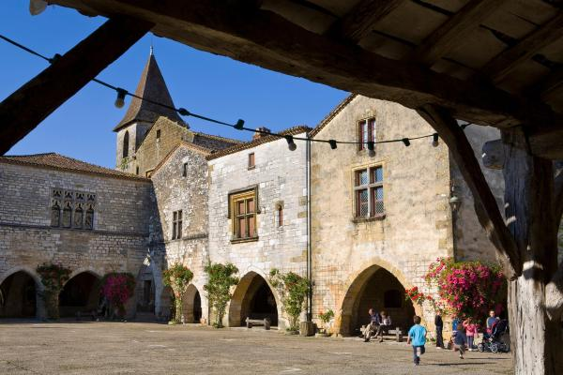
Rustic charm: MonpazierDOUG PEARSON/GETTY IMAGES
Top three villages
Monpazier
Medieval new towns were built in the southern Dordogne (and neighbouring areas) initially to ensure economic control over the locals, then as English or French frontline outposts in the Hundred Years’ War. Founded by England’s Edward I in 1284, Monpazier is the finest example. The bastide’s chunky stone arcades around a central square, and streets in chequerboard layout, strike everyone as perfect. Stay, and dine, at the manorial Hotel Edward I (doubles from £71; hoteledward1er.com).
Beaumont
Edward I built this one, too, just up the road. It’s maybe a little less perfect than Monpazier, but a little livelier. Bariat is the sort of floor-to-ceiling, we-sell-everything ironmongers — shotguns through to saucepans — that supplied your grandparents. In Prudence Kilgour, Beaumont has an Australian creator of perfumes with a feminine elegance unexpected in the land of goose fat (prudenceparis.com). And in the church, there’s a reliquary containing a single tooth from the mouth of St Martial. Nobody could ask for more, bar perhaps a hotel. Try the Vieux Logis, eight miles away (see Where to Stay).
Abjat-sur-Bandiat
So to the north of the county, where the Périgord Vert provides refuge from the main holiday routes in a green, watery landscape. Here, Abjat-sur-Bandiat makes a good base: it’s la France profonde all right, but with a pinch of Britishness for zest. At the Entente Cordiale bar, you may play Northamptonshire skittles or conkers, the legacy of English former owners (ententecordiale.net). La Cloche restaurant serves a full Sunday roast lunch for about £20 (laclocheabjat.com). And you might spot the expat author Fiona Barton (The Widow has sold zillions) bobbing about. Then fan out to the Périgord-Limousin National Park for walking (pnr-perigord-limousin.fr), the St-Estèphe lake for bathing and the Hostellerie St-Jacques, in St-Saud-Lacoussière, for dinner (menus from £35; hostellerie-saint-jacques.com). Bed down back in Abjat, at the modern, Dutch-run L’Auberge, where a snug studio apartment for two starts at £55 (aubergeabjat.com).
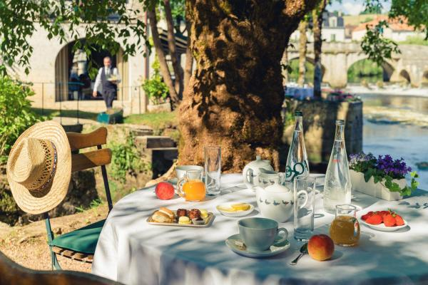
Lazy morning: breakfast is served at Moulin de l’Abbaye
Where to stay
Auberge de la Truffe, Sorges
This is essentially a jolly good restaurant that majors in the Dordogne mainstay la truffe (“the truffle”, as you may have guessed unaided). It is flanked by unpretentious rooms, the whole wrapped up in family-run informality. Pool and sauna are to hand, and the eating’s excellent even if you don’t push the boat out to the £98 truffle menu. The dinner menu at £17 will see you right. Doubles from £57; auberge-de-la-truffe.com
Domaine de la Rhonie, Meyrals
Drive the lane from the village until you fear you’re running out of world, then you’re there, at a working hilltop farm, its outbuildings (including tobacco-drying sheds) brightly adapted for guests, its roots deep (Marie-Rose is eighth generation), the food in its restaurant mainly home-produced and its spirit lively. You’ll be up with the lark for the outdoor life; when that’s done, more than 400 indoor and outdoor games banish boredom. Marie-Rose likes to keep you active. Doubles from £53; domainedelarhonie.com
Moulin de l’Abbaye, Brantôme
Americans see this place — a noble old watermill covered in greenery, its terrace jutting into the river, the monumental abbey alongside — and long to transport it to a site in Arizona. It’s that picturesque. The restaurant gained a Michelin star this year; the lounge and bedrooms exhibit a desire to mollycoddle. Doubles from £99; moulinabbaye.com
Château de Lalande, Annesse-et-Beaulieu
The chateau looks as if it’s migrated from the Loire Valley and predates the nearly-almost eponymous movie by a couple of centuries, so no evidence of Ryan or Emma. Attenuating disappointment are the sumptuous grounds, salons and rooms that are fit for the carriage classes, and a cracking restaurant. Doubles from £109; chateau-lalande-perigord.com
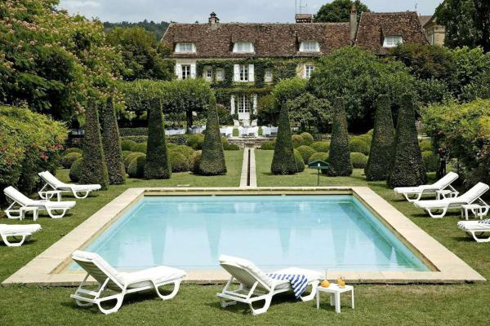
Picture perfect: the pool at Le Vieux Logis
Le Vieux Logis, Tremolat
A classic Dordogne hotel, manorial in aspect and with bespoke-tailored gardens. Within, the ancient — London-club salons; furniture from the days when if it didn’t weigh a ton, it wasn’t a wardrobe — is lightened with contemporary colour. Entering here, you’ll be co-opted into the ranks of the friskier rural aristocracy. And you’ll dine well in the Michelin-starred restaurant. Doubles from £128; vieux-logis.com
Gîtes
Gîtes punctuate the Dordogne landscape in villages, hamlets and lanes where they’ve not yet heard that the Hundred Years’ War is over. Look out for substantial honey-stone houses with gardens, pools, beams and a sense of slotting into a rural continuum. If you’re not finding something like that, look elsewhere.
The British-run Pure France has top-end properties round here, including the Manoir de Rouffillac, an 18th-cenury house 15 minutes from Sarlat. It’s a proper manor on 20-acre grounds, with four ensuite double bedrooms and most of the essentials for your promotion to the squirearchy. A week starts at £2,819 (purefrance.com).
The local specialist Simply Périgord, also British-run, has a similarly first-rate selection. New this year is Le Tabac, in a turbulence-free hamlet near Le Bugue. An old stone property that sleeps eight, with gardens and a pool, it has apparently grown organically from the landscape. A week starts at £1,626 (simply-perigord.com).
Getting there
The handiest airport is Bergerac, served in summer by Ryanair from Stansted, Bristol, East Midlands and Liverpool; by Flybe from Southampton, Birmingham and Exeter; and by Jet2 from Leeds Bradford. The Dordogne is accessible by rail: the journey from London to Périgueux takes from 9½ hours, and returns start at £151 (0844 848 5848; voyages-sncf.com).
Dordogne tips
If you’re in the northeast of the region, visit Tourtoirac: lovely village, fine cave and, best of all, a small museum dedicated to Orélie-Antoine de Tounens, a local man who, in 1858, left a Dordogne law practice for South America to become king of Araucania and Patagonia.
By and large, the people feeding you here will not understand the concept of vegetarianism. You’ll need to be precise — and emphasise, for instance, that the omelette should come without lardons.
Send us your Dordogne tips and win free flights
Which of your favourite spots and things to do have we missed? Send your tips to travel@sunday-times.co.uk. Our favourite letter will win its sender a pair of return flights with Monarch. Go to thesundaytimes.co.uk/travelletters for more details.
Share
Save

Related links

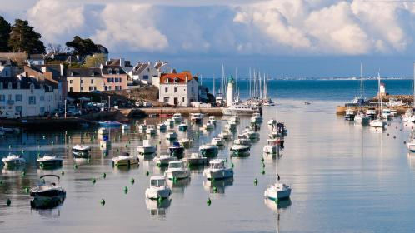

FRANCE

Great Brittany
Anthony Peregrine
In July, Ryanair opens up another service to somewhere you’ve never heard of. This time, it’s not at the far end of Europe and unpronounceable...
March 12 2017

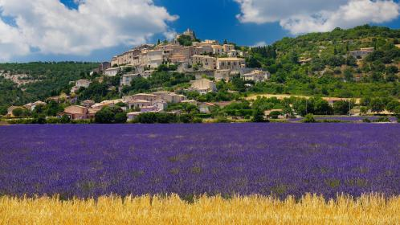

FRANCE

Essential Provence
Anthony Peregrine
More than any other European region, Provence nourishes northern dreams and sensual aspirations. You get there, you throw off your woolly, you...
January 29 2017

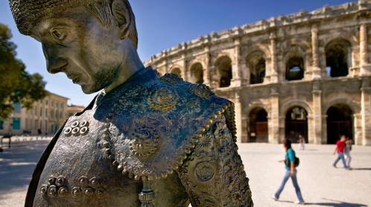

FRANCE

The big weekend: Nimes & Arles
Oliver Thring
SATURDAY
Morning
Winter might seem a counterintuitive time to visit these two well-preserved glories of Roman France — most tourists, of...
November 27 2016

This Australian destination is changing the face of modern science
From cutting-edge anti-flu drugs to alternative medicine, how the Gold Coast is making waves in the scientific community.
SPONSORED

Comments are subject to our community guidelines, which can be viewed here.

