Instructions for the use of appliances/AV equipment

Up to date manuals for the dishwasher, washer-dryer and oven can be found on the ‘documents’ section of the website (www.astorchamonix.com)

DREAMSTREAMS IPTV
We have IPTV with English freeview and paid channels, Sky Sports and Movies in multiple languages. Turn the TV on using the black TV remote and select HDM1 using the source button.
Turn the android TV box on using the android tv box unbranded remote.
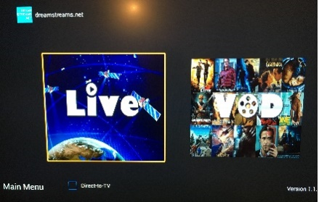
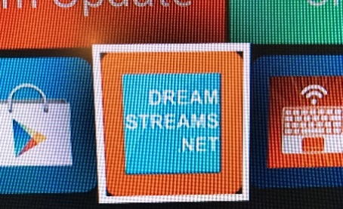
Click the Dreamstreams.net icon Select Live TV > You’re good to go!

DVD / NINTENDO WII – ENSURE THE ANDROID TV BOX IS TURNED OFF
- To use the DVD player or use the Nintendo Wii you have to change the input on the TV. In order to do this use the black TV remote.
- Press ‘Input’ button. Scroll down the list by using the arrows and then press ‘OK’ to select the option you require.
- 1 is DVD
- 2 is Nintendo Wii.

ORANGE (FRENCH TV)
- Orange TV is on HDMI 2

Spare batteries for all remotes and handsets can be found in the tall white cabinet.

